Skills checks cover pre-requisite material needed for the first unit of the course, areas & volumes. Answer the following questions neatly and completely. Calculators are not allowed.

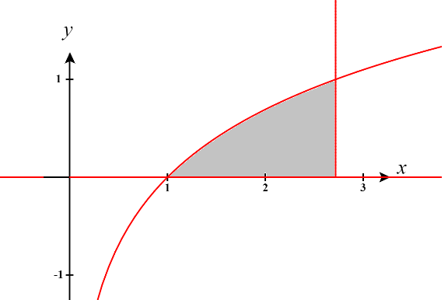
- Shade the region defined by the following curves: .

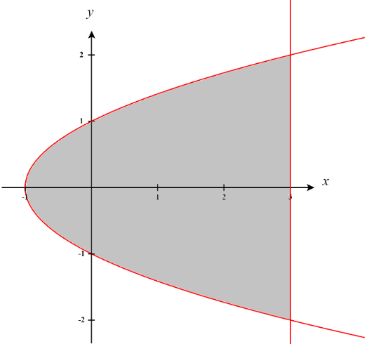
- Shade the region bounded by the following curves: .

- Shade the region bounded by the following curves: .

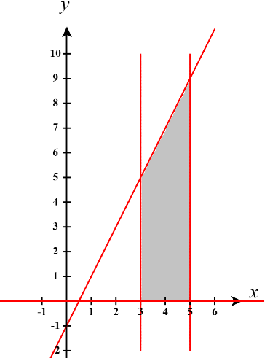

- Find the points of intersection of the curves: .
We find the point of intersection by setting the equations equal.
We have
These values of y correspond to the intersection points .

- Find the points of intersection of the curves: .
We find the point of intersection by setting the equations equal.
We have
These values of x correspond to the intersection points .

- Find the points of intersection of the curves: .
We find the point of intersection by setting the equations equal.
We have
These values of x correspond to the intersection points .

- Evaluate the definite integral: .

- Evaluate the definite integral: .

- Evaluate the definite integral: .
- Use a u-substitution to evaluate the definite integral: .
Let , then .
Our bounds become .
So we have

- Use a u-substitution to evaluate the definite integral: .
Let , then .
Our bounds become .
So we have
- Use a u-substitution to evaluate the definite integral: .
Let , then .
Our bounds become .
So we have
- Solve the equation for x: .

- Solve the equation for x: .

- Solve the equation for x: .

